1. Part 1: general usage: "cv1-problem1.exe imagepath scalefactor tx ty px py theta lambda histogram". All transformations are combined. Output image name: “outno1.pgm”

Imagepath = “comments.pgm”.

Scalecator: factor if needed, if not input = 1.

Tx & ty: for translation if needed, if not input = 0 & 0.

Px, py, & theta: for rotation around arbitrary if needed, if not inputs = 0.

Lambda: for power transformation, if not needed input = 1.

Histogram: 1 if needed, 0 if not.

Identity image:



Samples:

Original:

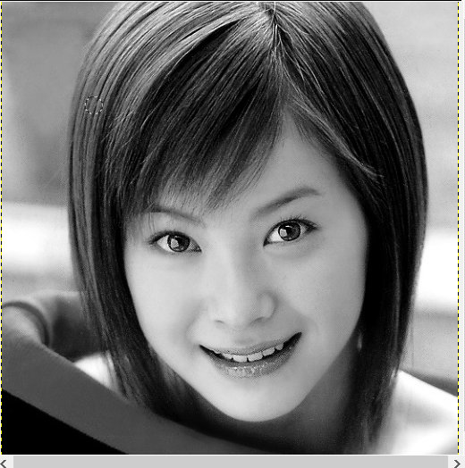

Translate 250, 400:

­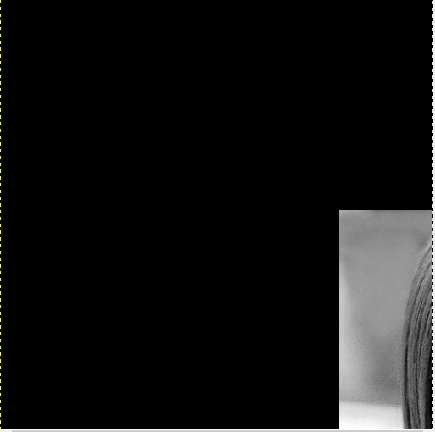

Rotate 30 around (250, 250):

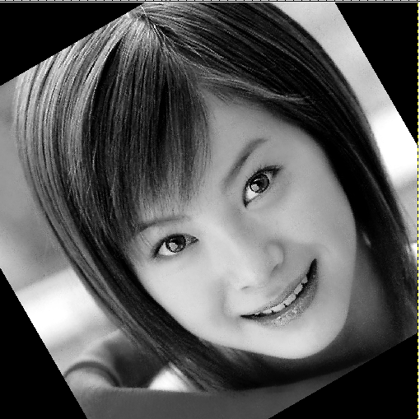

Power transformation: y = 10:

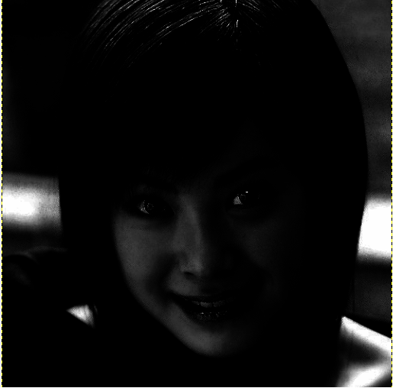

Power transformation y = 0.1:

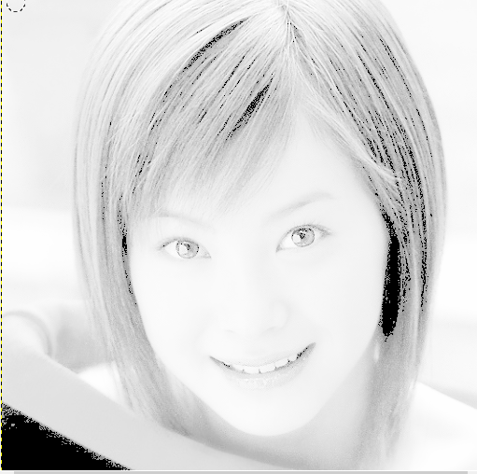

Histogram to the last image (y = 0.1):

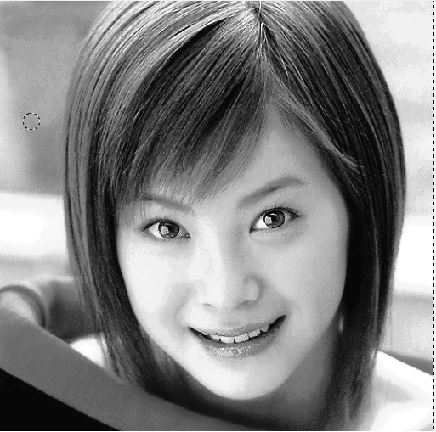

1. Part 2: general usage: "cv1-problem2.exe imagepath Smoothing Gradient Sharpening". Just one filter can be selected by input = 1 and others = 0. Smoothing uses an averaging filter. Output image name: “outsm.pgm”.

Identity:



Original:

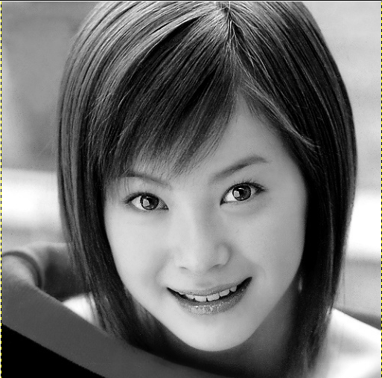

Smoothing:

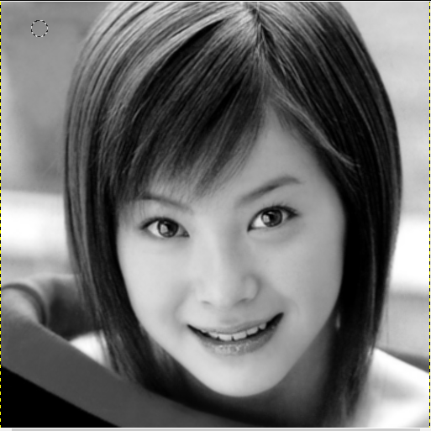

Gradient:

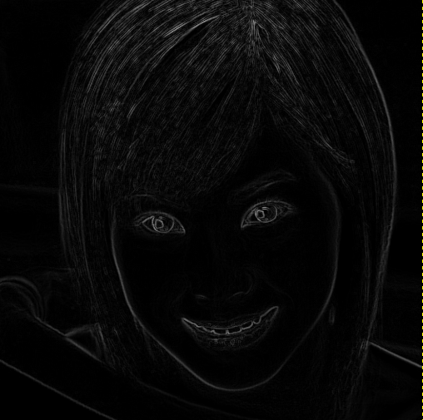

Sharpening:

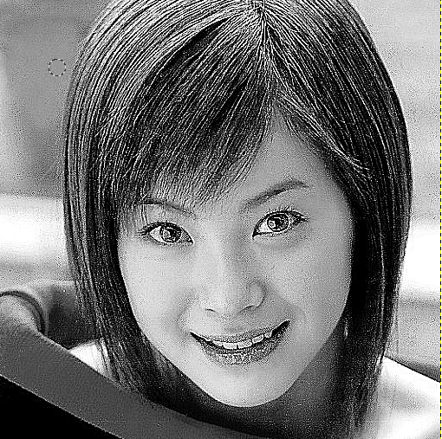

1. Part 3:
2. 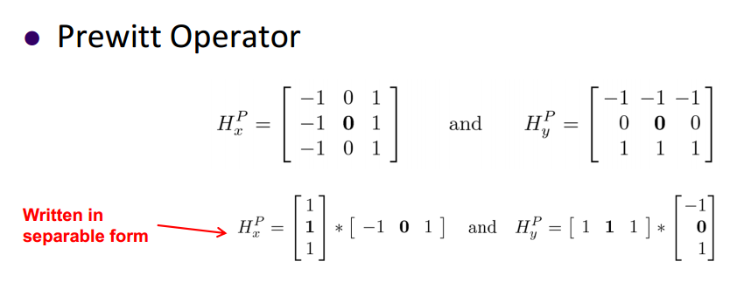
3. general usage: "cv1-problem3.exe imagepath mode”. For 1) mode = 0, for 2) mode = 1. Output image name: “outsm.pgm”.

Original:

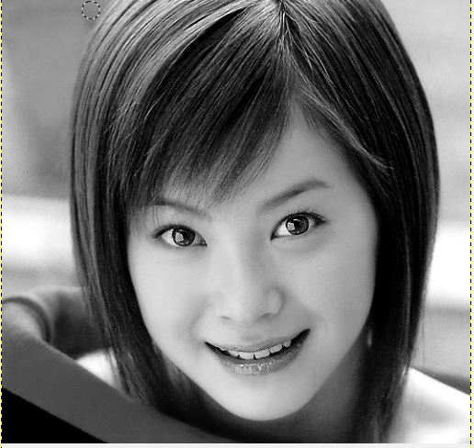

1. Applying the averaging filter (matrix of 9 ones then averaged automatically)

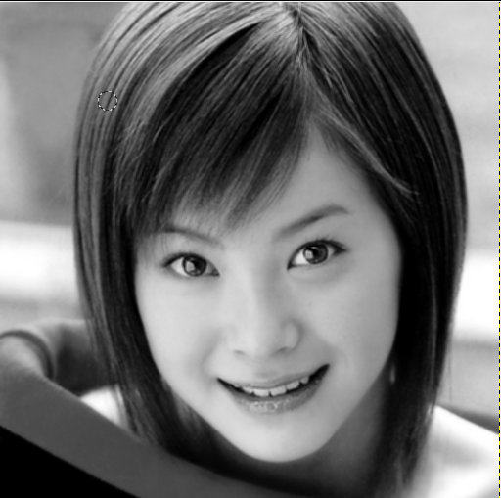

1. Applying the averaging filter (col {1 1 1} \* row {1 1 1}) then averaged automatically:

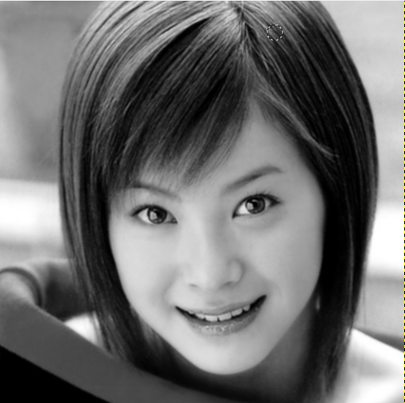

3- execution time: comparing codes for 1) & 2) -> approx. same execution time for same filter size.

For different filter size: the growth is directly proportional to the number of elements in the filter.

3x3 -> 1) 13 ms, 2) 11 ms.

5x5 -> 1) 23 ms, 2) 21 ms.

7x7 -> 1) 43 ms, 2) 40 ms.

11x11 -> 1) 96 ms, 2) 92 ms.

Bonus:

Home-made camera setup:

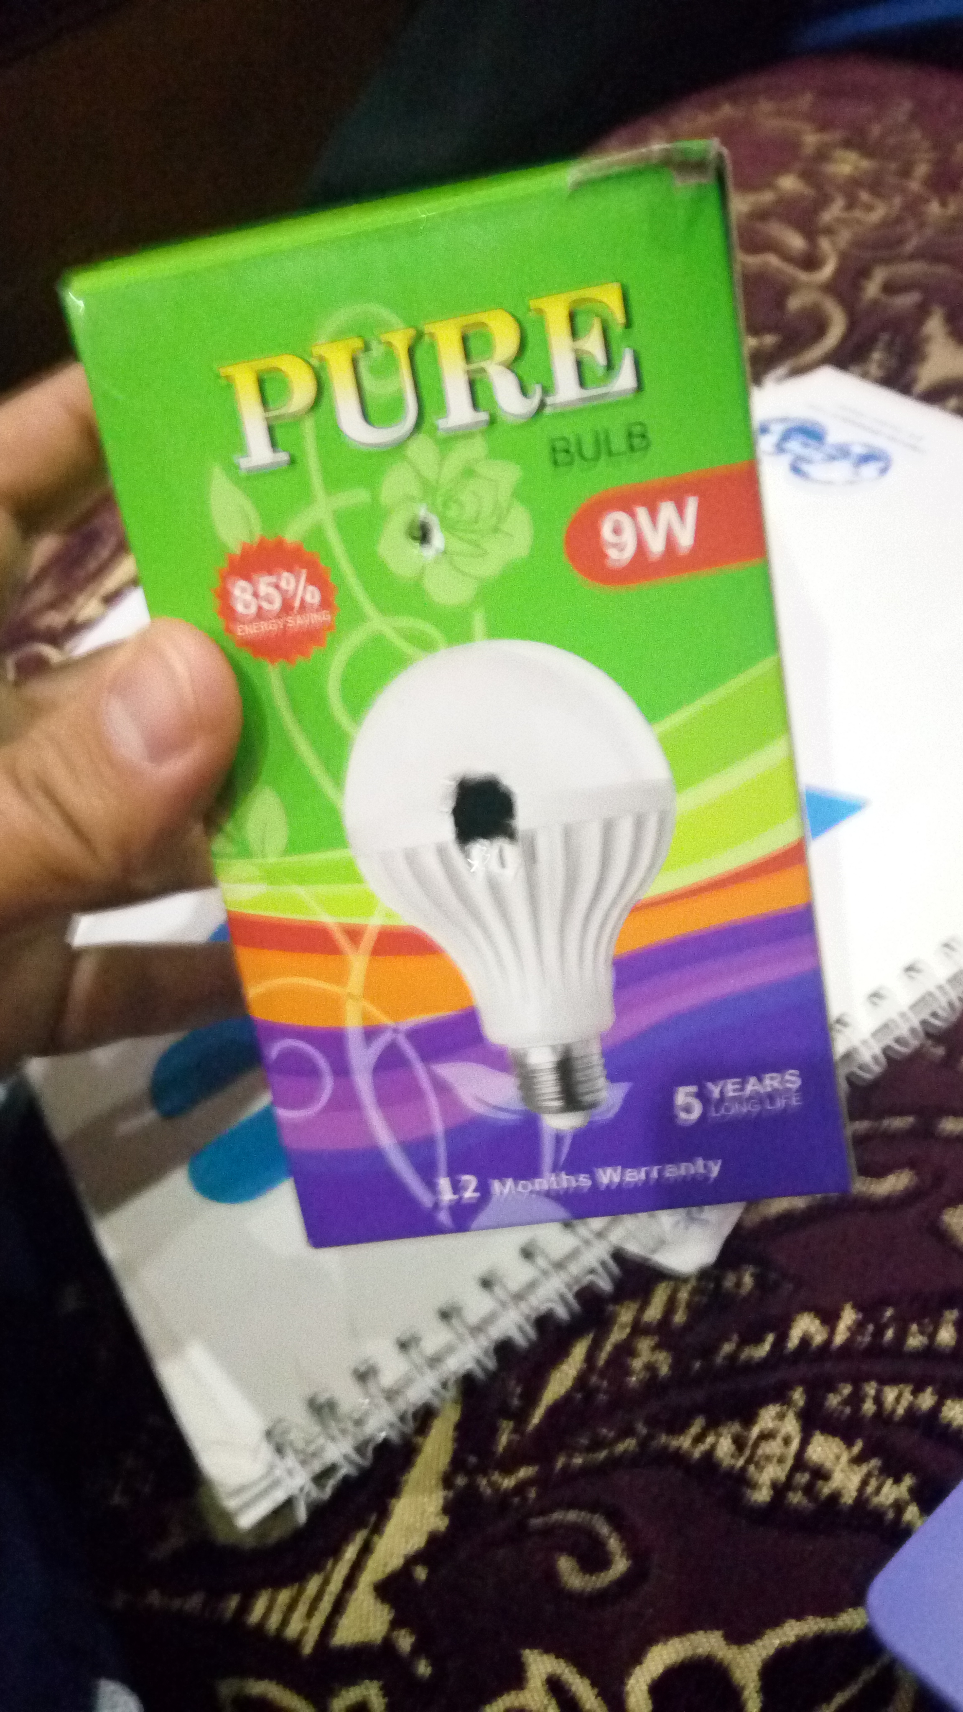

Images taken with it:

